

A Report

On

**Placement Management System**

By

**Sony Vanze**

**Anjali Kumbhar**

**Amruta Chaware**

**Priyanka Mahale**

**Gayatri Kale**

Batch : 2020-5732

Centre : Pune

Under The Guidance of,

**Jayanth V.**

**( Domain Trainer )**

( EduBridge Learning Training Centre )

## Introduction:

Our project explains about the Placement Management System.This project mainly explains the various actions related to placement . We provide four types of courses like Software Development,Software Testing,Web Development, Database. Student can able to enrol for this courses at the time of registration and also able apply for the drives for placements after successfully completion of training. Teacher has separate Login and Registration. Teacher can able to see all student details regarding course,placement and also able to update course completion status. Admin can able to view all details regarding Teachers, Students and placement activities.

Our Project Include **Modules:-**

* Admin Module
* Student Module
* Teacher Module

## Technologies:

* Eclipse IDE
* Java – Servlet and JSP, Hibernate
* HTML,CSS, Bootstrap
* MySQL

The main feature of the project is to make training and placement easier for student as well as for institute. Student can learn and teacher can teach from everywhere.

In Admin module, admin can add the Teacher, Student, Course, Company drive. He can also view the total number of students, teacher, company count and student placement records. And course and course completion details also.

In Student module, student can access the website and enroll for course and can able to get the placement. New student can register and login after that able to attend learn and apply for placement.

**Software Requirements:**

**Front end:**

Java/J2EE technologies (Servlet, JSP), HTML, CSS, Bootstrap, Hibernate.

**Back end**: MySQL workbench 5.6

**Middleware/Server:** Apache Tomcat 7

**IDE**: Eclipse IDE

**Browser:** Best result on Google Chrome

**Operating System:** Window 8/10.

**Screenshots**:-

**Home Page**

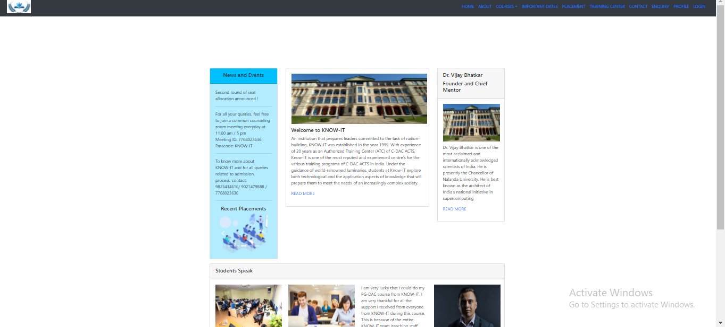

**Login Page**

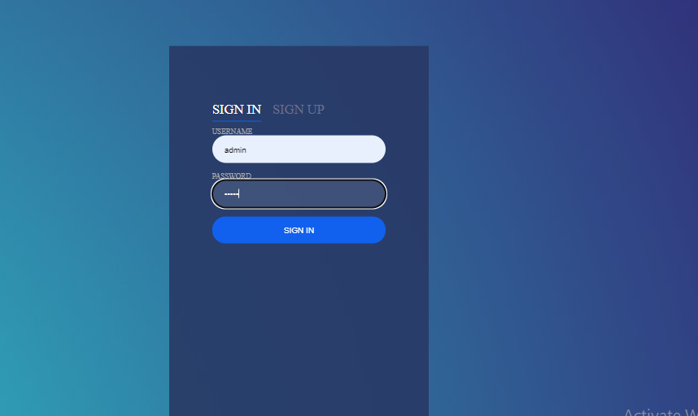

**Registration Page**



**Teacher Profile Page**

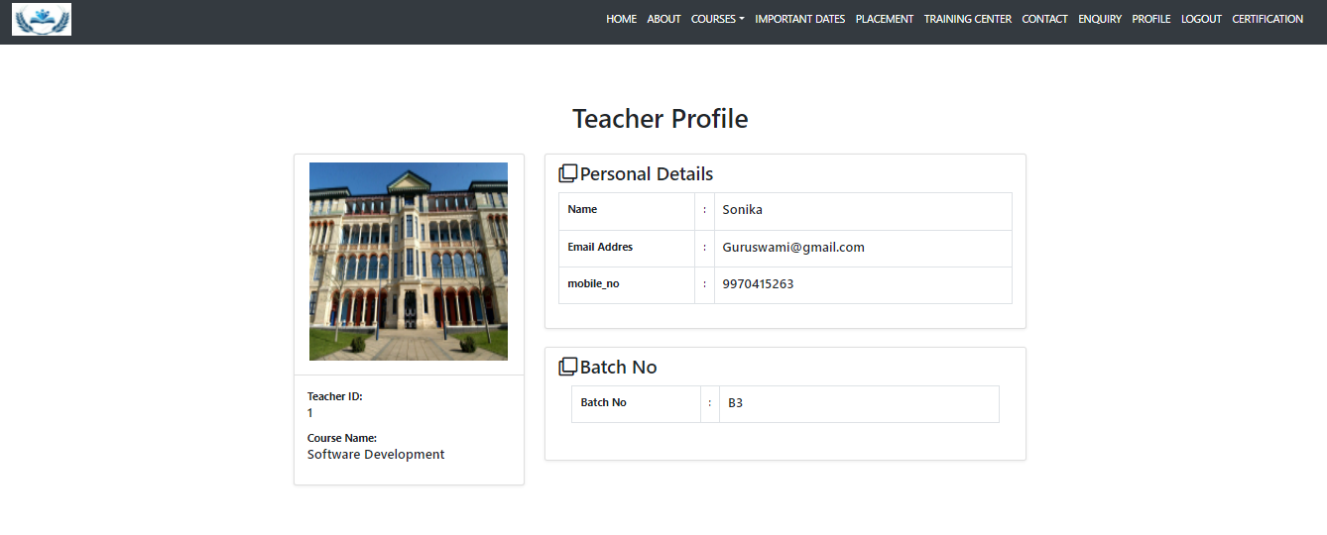

**Company Database**

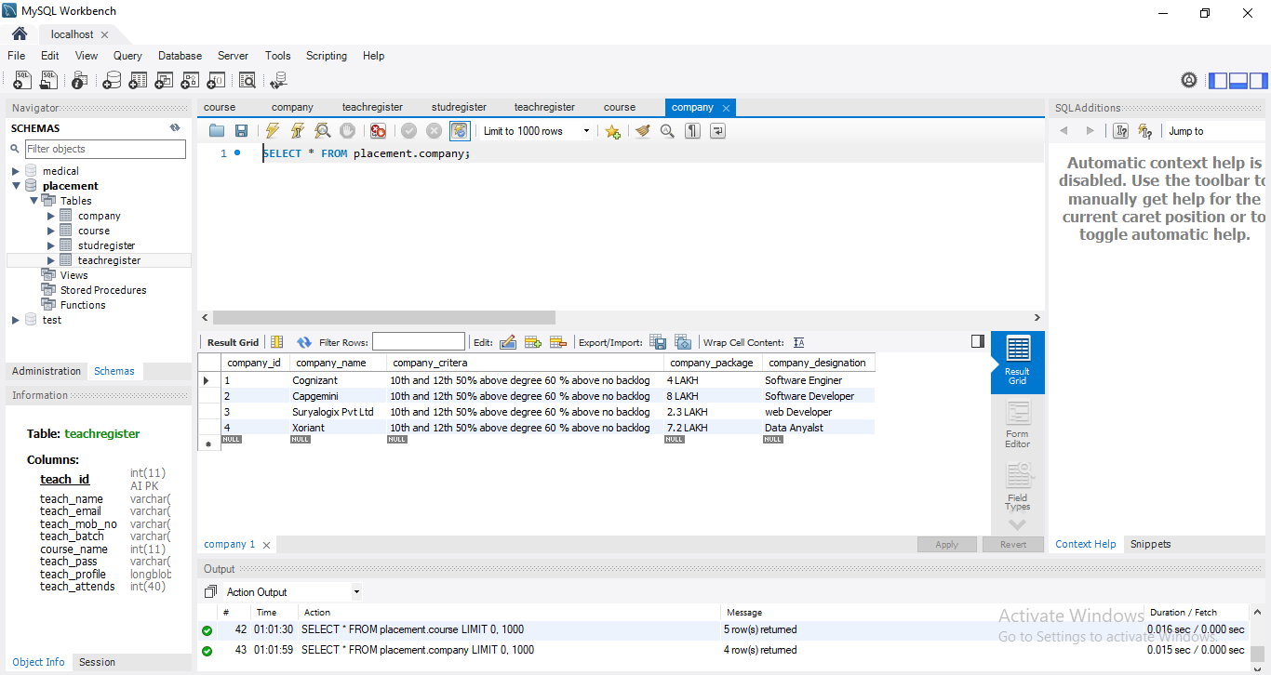

**Course Database**

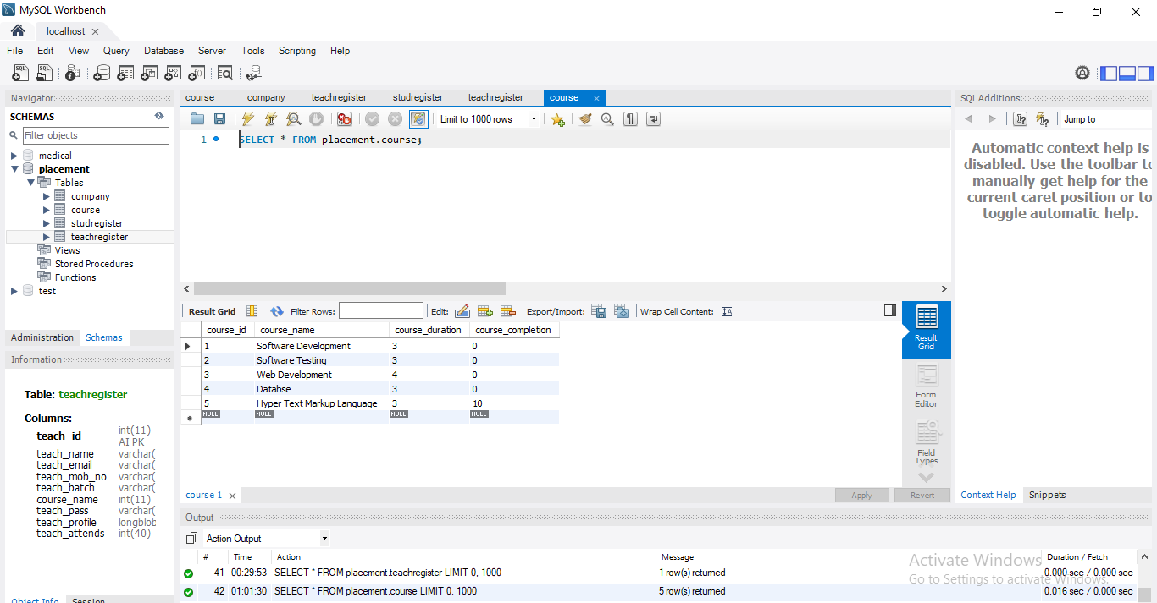

**Student database**

